topic | HALLUX VALGUS (BUNION)
Procedure | SCARF & AKIN OSTEOTOMY (W7910 +W1040)
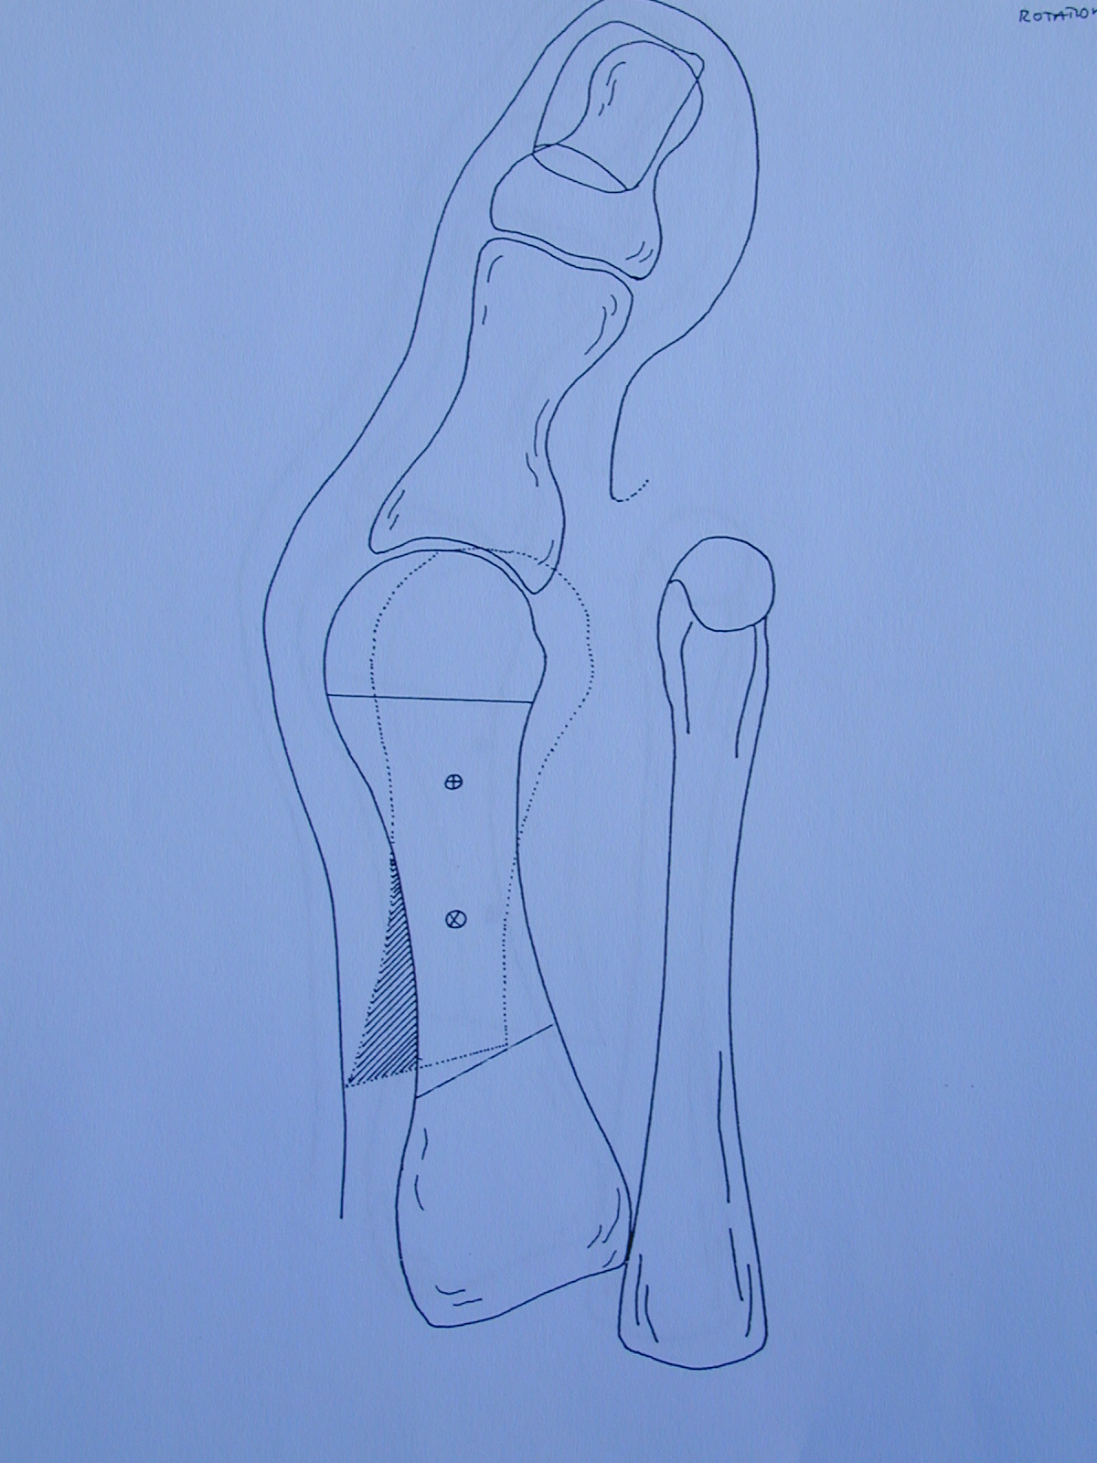 | 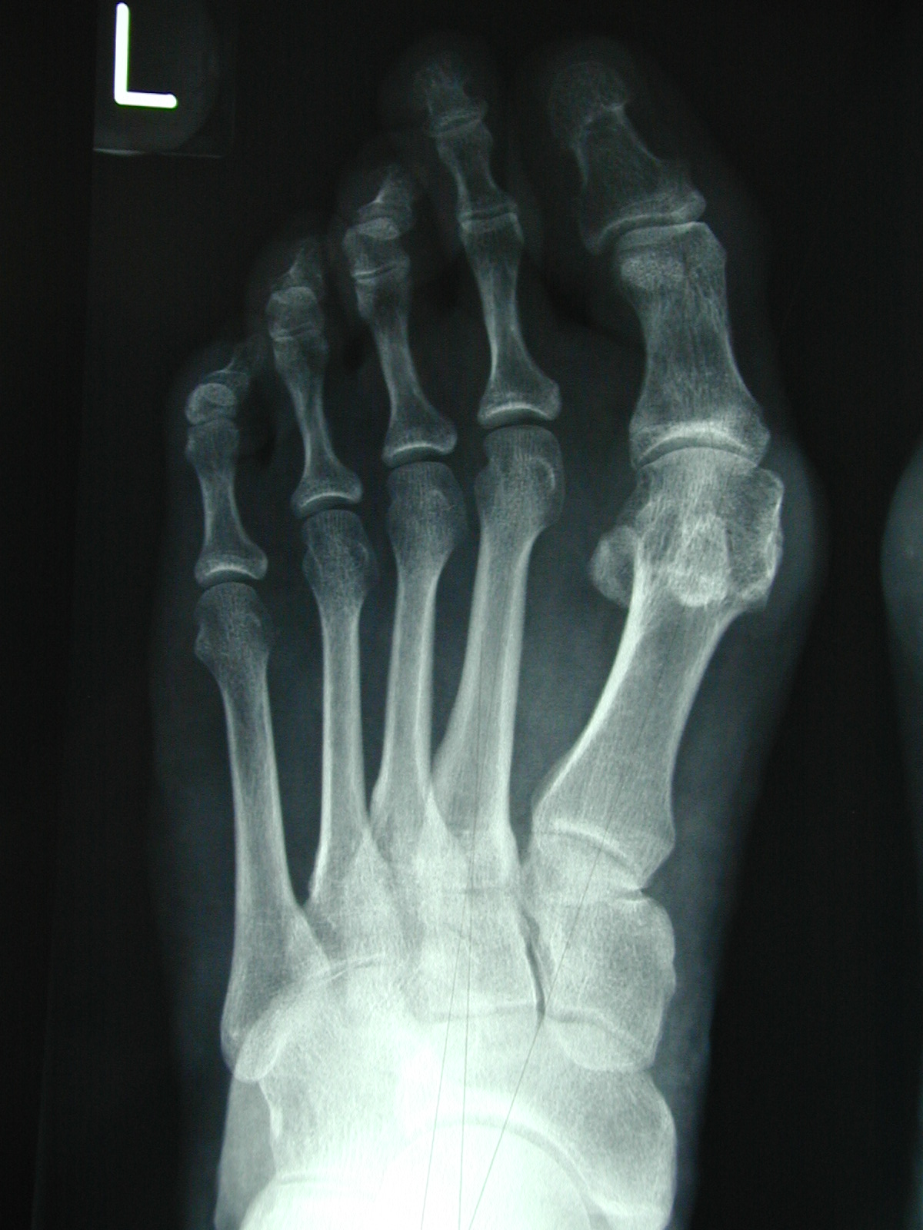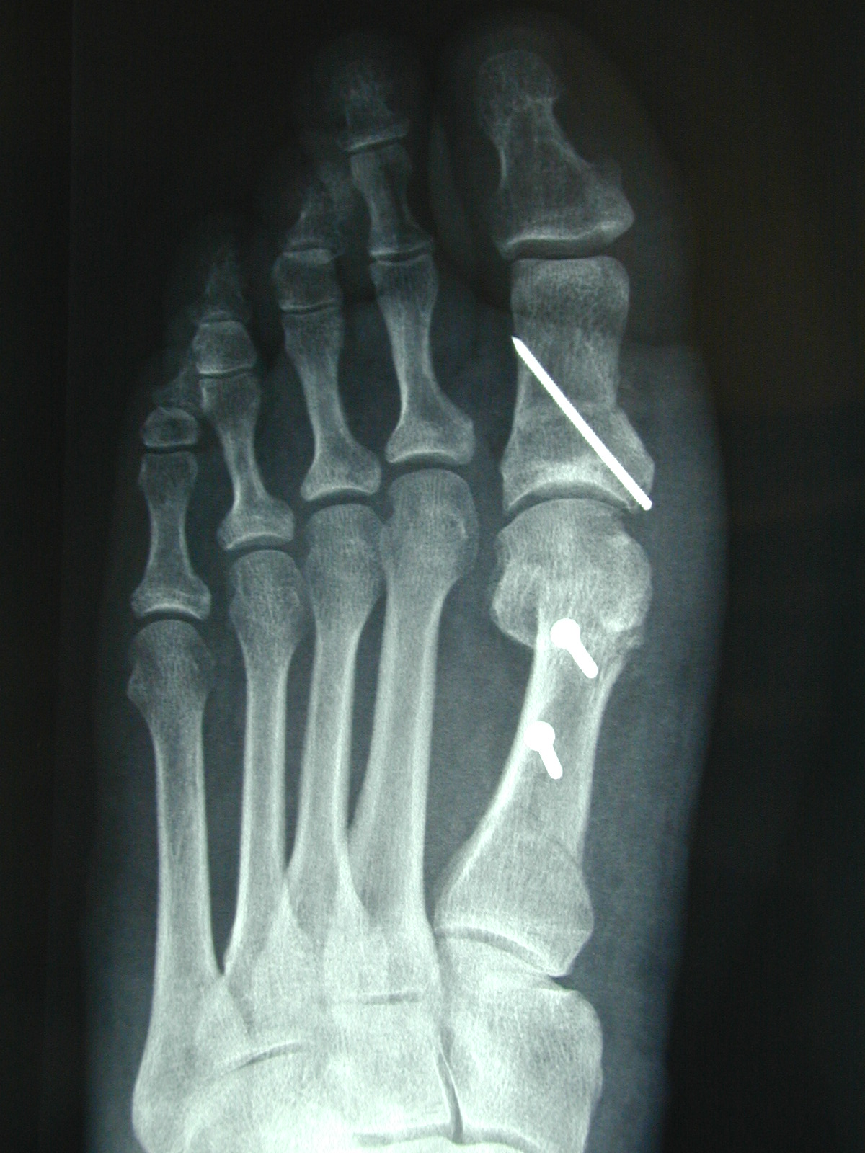
AIMS OF SURGERY | To reduce pain and deformity.  To improve the big toe alignment [make straighter].
advantages of THIS OPERATION | Reduces the poor alignment which is the cause of the deformity
SPECIFIC RISKS of THIS OPERATION | Joint stiffness (8%)  Over correction 4%  Pain in ball of foot – transfer pain(6%)  Recurrence of deformity (8%).  Footwear restriction (14% cannot wear high heels) | Screws need removal in 25% over 10 year period after the op  Big toe joint pain (6%)  Wound infection 4%  Revision surgery required in 2%  Failure to achieve full correction

OVERVIEW
Operation time | Usually 45 minutes
Incision placement / stitches | Usually on top or the side of the foot and with absorbable stitches where possible
Procedure | The toe is straightened by cutting and realignment of the bones either side of the big toe joint.
Fixation | Internal fixation (plates, screws or pins) are usually used  You will not normally notice these and they do not usually need to be removed font wrong
Will I have plaster? | No
Is this a Day Procedure? | Yes, you can usually go home the same day
Estimated time off work | Non-manual work approximately 4-6 weeks  Manual work 6-8 weeks
INDICATIONS FOR The procedure | Hallux Valgus deformity, Pain from prominent joint  Difficulty with shoe fit despite wearing sensible footwear
ALTERNATIVE TREATMENTS | Manage your symptoms by altering activity levels, using painkillers and anti inflammatories, changing footwear (including bespoke), joint injection therapy and using an insole or orthotic foot support (The use of insoles / orthoses or toe splints has not been shown to correct toe deformity).
GENERAL RISKS OF SURGERY | The general risks of foot surgery are outlined in the Pre-operative Information Booklet which is provided in addition to this leaflet  YOU SHOULD READ THIS LEAFLET IN CONJUNCTION WITH THE PREOPERATIVE INFORMATION BOOKLET
MORE INFO By: | 1 Speaking with your consultant or one of his team  2 Reading the information provided
Rotational Scarf & Akin Osteotomy

The operation can be performed comfortably under a Local Anaesthetic block, which is achieved by either a series of injections around the Ankle, or an injection behind your Knee. You will be fully awake during the operation and will be able to feel touch, pressure and vibration, but you will not feel any pain. If you do not wish to consider having the operation performed whilst still awake, or your Consultant does not feel this is the best option for you, you will be offered Local Anaesthetic with sedation or General Anaesthesia. If this is the case then you may need to be referred to a different surgical team to facilitate this and your consultant will be happy to discuss with you further.

The operation takes about 30-45 minutes although you will be in the Day Surgery unit for some time before the surgery and afterwards, to allow you an opportunity to rest post operatively. You must have a competent adult at home for the first day and night after surgery. This allows us to be sure you will be safe for the first night.

First 2-4 days
- This is the time you are likely to have most pain but you will be given painkillers to help. You must rest completely for 2-4 days.
- You will be able to stand and take weight carefully (using crutches) after the operation, but you must rest, with your feet up, as much as possible.
- You should restrict your walking to going to the bathroom and when getting about use your crutches in the way you will have been shown.
- You can get about a little more after 3 days.

One week after surgery
- You may need to attend for your foot to be checked and re-dressed.
- You may start to do a little more within pain limits. Pain & swelling means you are doing too much.

Two weeks after surgery
- Sutures will be removed if necessary.
- You will not need a bandage or crutches any longer and can get the foot wet.
- You will be asked to start wearing trainer type shoes.
- You may be asked to move your toe through a range of motion to maintain mobility.
- Many patients return to shoes after 2 weeks (29%), although this may take longer

Between 2-6 weeks after surgery
- The foot starts to return to normal and you can return to shoes (88% of patients by 8 weeks).
- The foot will still be quite swollen especially at the end of the day.
- You may require a review appoint at 4-6 weeks
- You may return to work but may need longer if you have an active job
- You may return to driving if you can perform an emergency stop. You must check with your insurance company before driving again.
- Whilst normal activity will be resumed, sport should be avoided.

Between 8-12 weeks after surgery
- The foot should continue to improve and begin to feel normal again.
- There will be less swelling.
- Sport can be considered after 3 months depending on your recovery.

Six months after surgery
- You will have a final review between 3- 6 months following surgery.
- The swelling should now be slight and you should be getting the full benefit of surgery.

Twelve months after surgery
- The foot has stopped improving with all healing complete.

Please note, if a complication arises, recovery may be delayed. If you develop a complication please contact the unit.

Data information taken from:
PASCOM National Audit tool for Podiatric Surgeons. College of Podiatrists

