topic
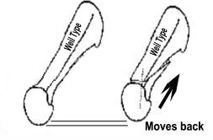  Procedure |  | Weil lesser metatarsal osteotomy (W1590)
 | 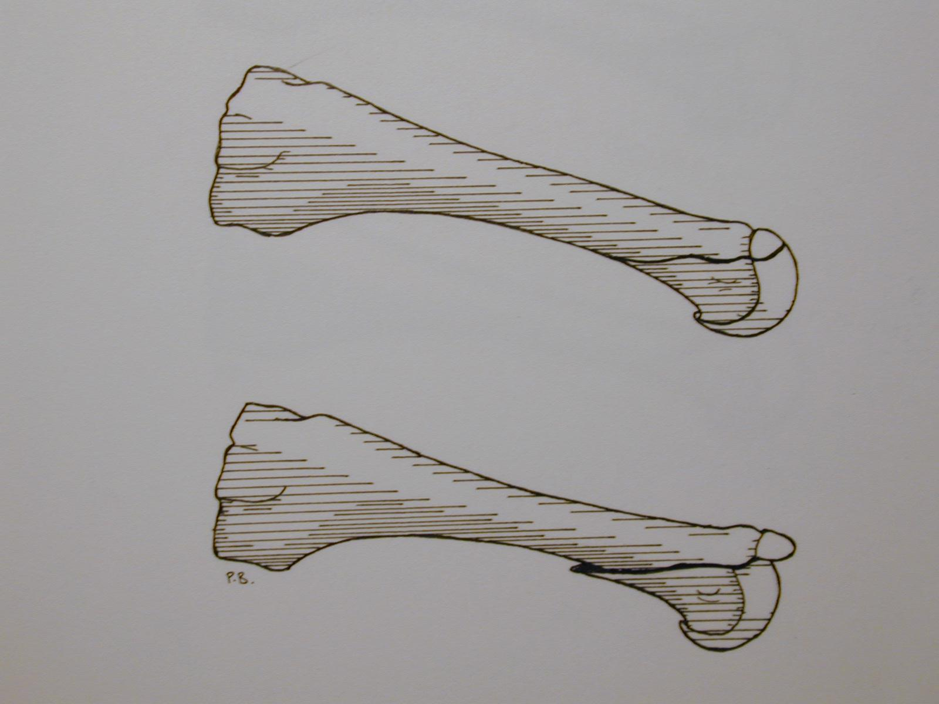
AIMS OF SURGERY |  | Reduce deformity and prominent joint
advantages of THIS OPERATION |  | The shortening/reduction of prominence is predictable  The underlying cause of the pain and deformity is reduced  The need for routine podiatry care is reduced
SPECIFIC RISKS of THIS OPERATION |  | The toe floats above the floor in 20%  joint stiffness10%  Transfer of weight to a neighbouring joint under the ball of the foot 2.5% | Infection in 7.5%  Recurrence of symptoms 2.5%

OVERVIEW
Operation time | Usually between 30 - 45 minutes
Incision placement / stitches | On the top of the foot over the bone to be corrected and with absorbable stitches where possible
Procedure | The affected metatarsal bone is cut, shortened and re-aligned
Fixation | A wire or screw is used to hold the bone cut together. You will not notice these and they do not usually need to be removed
Will I have plaster? | No
Is this a Day Procedure? | Yes, you can usually go home the same day
Estimated time off work | Non-manual work approximately 4-6 weeks  Manual work 6-8 weeks
INDICATIONS FOR The procedure | Pain / callous / corn formation beneath the ball of the foot  Severe toe deformity to allow relocation of toe  Difficulty with shoe fit despite wearing sensible footwear
ALTERNATIVE TREATMENTS | Manage your symptoms by altering activity levels, using painkillers and anti inflammatories, extra depth / width shoes, rocker sole (stiff curved sole) using an insole or orthotic foot support, joint injection therapy. Regular podiatry care to reduce painful lesions. Steroid injections for painful joints
Patient reported outcomes | In a study of 40 feet at 18 months post op, 85% of patients were completely satisfied,
GENERAL RISKS OF SURGERY | The general risks of foot surgery are outlined in the Pre-operative Information Booklet which is provided in addition to this leaflet  YOU SHOULD READ THIS LEAFLET IN CONJUNCTION WITH THE PREOPERATIVE INFORMATION BOOKLET
MORE INFO By: | 1 Speaking with your consultant or one of his team  2 Reading the information provided
Lesser metatarsal Surgery for ball of the foot pain

The operation can be performed comfortably under a Local Anaesthetic block, which is achieved by either a series of injections around the Ankle, or an injection behind your Knee. You will be fully awake during the operation and will be able to feel touch, pressure and vibration, but you will not feel any pain. If you do not wish to consider having the operation performed whilst still awake, or your Consultant does not feel this is the best option for you, you will be offered Local Anaesthetic with sedation or General Anaesthesia. If this is the case then you may need to be referred to a different surgical team to facilitate this and your consultant will be happy to discuss with you further.

The operation takes about 30-45 minutes although you will be in the Day Surgery unit for some time before the surgery and afterwards, to allow you an opportunity to rest post operatively. You must have a competent adult at home for the first day and night after surgery. This allows us to be sure you will be safe for the first night.

First 2-4 days
- This is the time you are likely to have most pain but you will be given painkillers to help. You must rest completely for 2-4 days.
- You will be able to stand and take weight carefully (using crutches) after the operation, but you must rest, with your feet up, as much as possible.
- You should restrict your walking to going to the bathroom and when getting about use your crutches in the way you will have been shown.
- You can get about a little more after 3 days.

One week after surgery
- You may need to attend for your foot to be checked and re-dressed.
- You may start to do a little more within pain limits. Pain & swelling means you are doing too much.

Two weeks after surgery
- Sutures will be removed if necessary.
- You will not need a bandage or crutches any longer and can get the foot wet.
- You will be asked to start wearing trainer type shoes.
- You may be asked to move your toe through a range of motion to maintain mobility.

Two weeks after surgery
- Sutures will be removed if necessary.
- You will not need a bandage or crutches and can get the foot wet.
- You will be asked to start wearing trainer type shoes.

Between 2-8 weeks after surgery
- The foot starts to return to normal and you can return to normal shoes (6-8 weeks)(89%).
- The foot will still be quite swollen especially at the end of the day.
- You may return to work but may need longer if you have an active job.
- You may return to driving if you can perform an emergency stop. You must check with your insurance company before driving again.
- Whilst normal activity will be resumed, sport should be avoided.

Between 8-12 weeks after surgery
- The foot should continue to improve and begin to feel normal again.
- There will be less swelling.
- Sport can be considered after 3 months depending on your recovery.

Six months after surgery
- You will have a final review between 3- 6 months following surgery.
- The swelling should now be slight and you should be getting the full benefit of surgery.

Twelve months after surgery
- The foot has stopped improving with all healing complete.

Please note, if a complication arises, recovery may be delayed. If you develop a complication please contact the unit.
Data information taken from:
O’Kane C, Kilmartin TE, The surgical management of central metatarsalgia. Foot & Ankle 2002 23:415-419

